Basic statistics

.
What is statistics?
A.L. Bowley defined statistics as
‘Statistics may be called the science of counting’.
A definition due to W.I. King is

‘Statistics may be defined as the science of collecting, organizing, analyzing, summarizing, interpreting numerical data and making valid inferences or conclusion on the base of the data.’

Basically there are three steps involved in statistics:
1) Specification of the information required to achieve the objectives
of the study;
2) Analysis of the information;
3) Interpretation of the results

Types of statistics:

There are two types of statistics
1. Descriptive statistics
2. Inferential statistics.

1. Descriptive Statistics: Descriptive statistics involve graphical and numerical procedures that are used to summarize and process data and to transform data into information.

Example:
A Gallup poll found that 49% of the people in a survey knew the name of the first book of the Bible. The statistic 49 describes the number out of every 100 persons who knew the answer.

2. Inferential Statistics: inferential statistics are used to make inferences about a population from a sample in order to generalize (make assumptions about this wider population) and/or make predictions about the future. Inferential statistics provide the bases for prediction, forecasts and estimates that are used to transform information into knowledge.

Example:
TV networks constantly monitor the popularity of their programs by hiring Nielsen and other organizations to sample the preferences of TV viewer

Some important definitions:

Population: A Population is a Collection of all possible individuals, objects, or measurements of interest.

Sample: A sample is a representative part of the population.
Census: Collection from every member of a population.

Parameter: A Parameter is a measurable characteristic of a population.

Statistic: A statistic is a measurable characteristic of a sample.
Data: Data Any characteristic that can differ from one individual to the next is called a variable. We call variables that are measured, or somehow determined, and collected on a number of individual’s data

Variable: That changes its characteristics with respect to different aspects. Such as height, weight etc.

Qualitative or Attribute Variable the characteristic being studied is nonnumeric. Example: Gender, Eye color, types of Car etc.

In a Quantitative Variable information is reported numerically. Example: Balance in your account, No of children in a family.

Quantitative variables can be classified as either Discrete or Continuous.

Discrete Variables can only assume certain values and there are usually “gaps” between values.
Example: the number of bedrooms in a house, or the number of hammers sold at the local Home Depot (1, 2, 3, etc).

A Continuous Variable can assume any value within a specified range. Example: the weight of a chop, the height of students in a class.

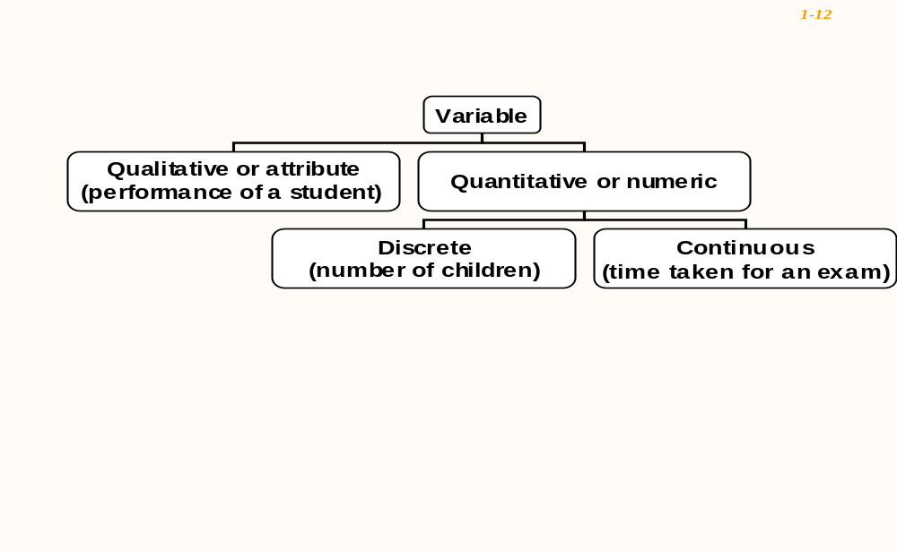

There are four levels of measurements: Nominal, Ordinal, Interval, and Ratio.

Nominal level: Data that is classified into categories and cannot be arranged in any
particular order. Example: Gender, Eye Color etc.

Ordinal level: involves data arranged in some order, but the differences between data values cannot be determined or are meaningless.
During a taste test of 4 soft drinks, Coca Cola was ranked number 1, Dr. Pepper number 2, Pepsi number 3, and Root Beer number 4.

Interval level: Similar to the ordinal level, with the additional property that meaningful amount of differences between data values can be determined. There is no natural zero point.Example: temparature in Fahrenheit scale.

Ratio level: The intervals level with an inherent zero starting point. Differences and ratios are meaningful for this level of measurement. Ex; Monthly income of a family.

Application of Statistics in Computer sciences engineering (CSE):

- Investigate the computational limits of the algorithms and data structures that support complex software systems.
- Develop new applications and tools in multi-disciplinary areas of science and research.
- Explore opportunities for advanced computer modeling and simulation.

